TLC for the Nervous System

Textured rhythms and easy transitions will guide you into a peaceful state of mind. In this guided meditation, Sharon Byrnes - yoga therapist and vibrant aging coach - will inspire you to find the peace that resides within you. Best of all, this will support you- novice or experienced meditator to personalize this experience to your present self. Find out more at www.vibrantaging.life.

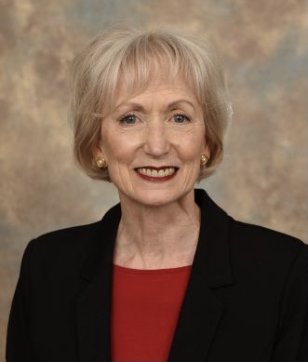
Sharon Byrnes is an experienced yoga teacher registered with Yoga Alliance and she is certified by the International Association of Yoga Therapists. She provides education, coaching, and customized programs to improve selfcare. Her mission is to empower people, especially those suffering from anxiety or depression, to live life well. Visit www.vibrantaging.life or call 513-658-1952 for information or to schedule a consultation.

Betsy Wurster loves travel and photography. She specializes in wildlife and landscape photography. For information or to download images, please email: betsywurster@gmail.com

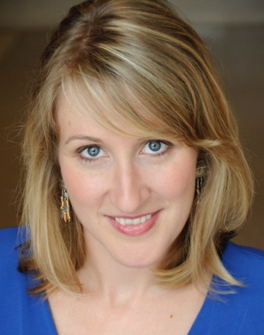
Amy Dennison of “Creation Station” is an eclectic musician and lifelong teacher/musician who plays musical instruments ranging from the flute to the flubber pipe. Amy’s two passions: creating accessible pathways that encourage music making for everyone, and to stimulate curiosity, creativity and sustainability through recycled instrument making. Contact info: afdennison@gmail.com

Ellen Graham is a vocalist, voice teacher and speaking coach whose evidenced-based functional approach to teaching has helped beginning to professional clients achieve their voice goals. As a vocalist, Ellen performs regularly in concert and opera, both in Cincinnati and around the county. Visit www.ellengrahammezzo.com for more info.

Special thanks to additional contributors: Pam Jurgens, harpist and Mary Rekers, percussionist.

